  Politeknik Negeri Bandung | Bahasa Inggris 2
 | Lecturer: Dra. Siti Yuliah, M.Pd.  Intan Sinta Dewi Rahayu, M.Pd.  Mira Nissa Murti, M.Pd.  Setya Resmini, M.Pd. | Skill Focus: Reading
 | Duration: 4x50’ | Topic 10: Semantic Mapping
Equipment: | White board, board marker, handout, projector, screen, laptop
Objectives: | After completing this lesson, you will be able to:  - explain the definition of semantic mapping  - explain the advantages of semantic mapping  - apply the concepts of semantic mapping  - apply strategies of semantic mapping
Student’s name |  | Date:

A. The Definition of Semantic Mapping
Semantic mapping or graphic organizing is a process for constructing visual displays of categories and their relationships. In its process, readers use maps or webs of words. The purpose of creating a map is to visually display the meaning-based connections between a word or phrase and a set of related words or concepts. Semantic maps help readers, especially struggling readers and those with disabilities, to identify, understand, and recall the meaning of words they read in the text.
B. Advantages of Semantic Mapping
When you are reading a text or part of a textbook often you are confused about the ideas and concepts that are explained. This is because probably there are many explanations and definitions, which then are related to other explanations and ideas. In fact, it is normal confusion experienced by every reader of such kind of text. However, there are ways and techniques to help you think in a simple way and help memorize the main ideas and key concepts.
You can reorganize and rearrange the most important ideas and information from reading or textbooks and convert it into diagrams with your own words. This is called ‘mapping’. Mapping what you read helps you understand and remember it. It is a useful studying technique because mapping makes it easier for the reader to organize and remember the main ideas and key concepts of the text they read. This technique can even be used as a pre-writing technique, or preparation of ideas before you write.
Indeed, semantic Mapping−Graphic organizers can be incorporated into the classroom in many different ways. Here are four examples of how you can use them:
- Pre-Reading - Graphic organizers can be used as a reading guide which will allow you to show the sequence and relationships, and prepares for important themes and concepts that they will discover while reading.
- Pre-Writing - Graphic organizers can assist you with brainstorming and mapping the relationship between a topic and its details. This strategy can be used to help narrow down a topic before beginning the writing process.
- Note-taking - While reading, you can create columns or charts to help them compare/contrast text. They can also outline details such as important facts and figures.
- Summarizing - You can use a cause/effect diagram which helps students to follow processes, make inferences, and draw conclusions.

C. How Do You Choose the Type of Map to be Used?
1. Use Charts or Matrixes to compare and contrast qualities, examples, descriptions, and facts.

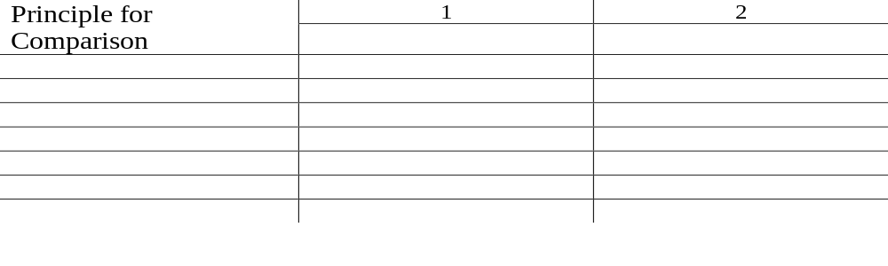
2. Use Stars or Spiders to show themes, examples, descriptions, and definitions.
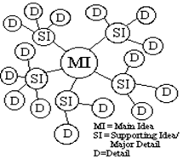

3. Use Trees or Hierarchies to show categories, classifications, analysis, structures, descriptions, and examples.

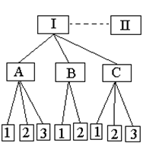

4. Use Chains to show processes, sequences, causes and effects, chronological order, and steps.

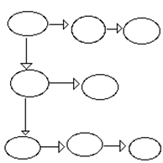
5. Use Flowcharts/Venn Diagrams to show relationships between diagrams, points of overlap, and points of distinction.

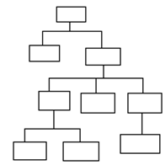

6. Use Sketches to show physical structures, visual images, concrete objects, spatial relationships, and descriptions of places.

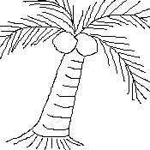
D. Practices

Task 1
Directions: Read the paragraphs about Dan and Don. Then fill in the character maps for each.
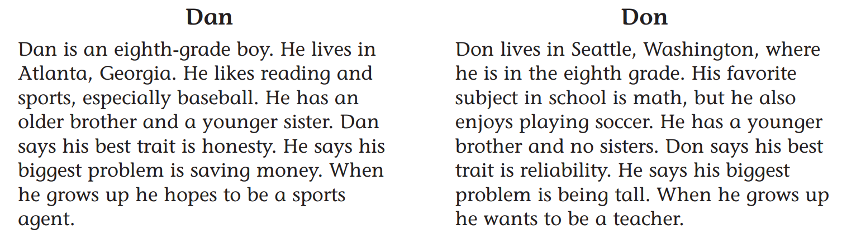

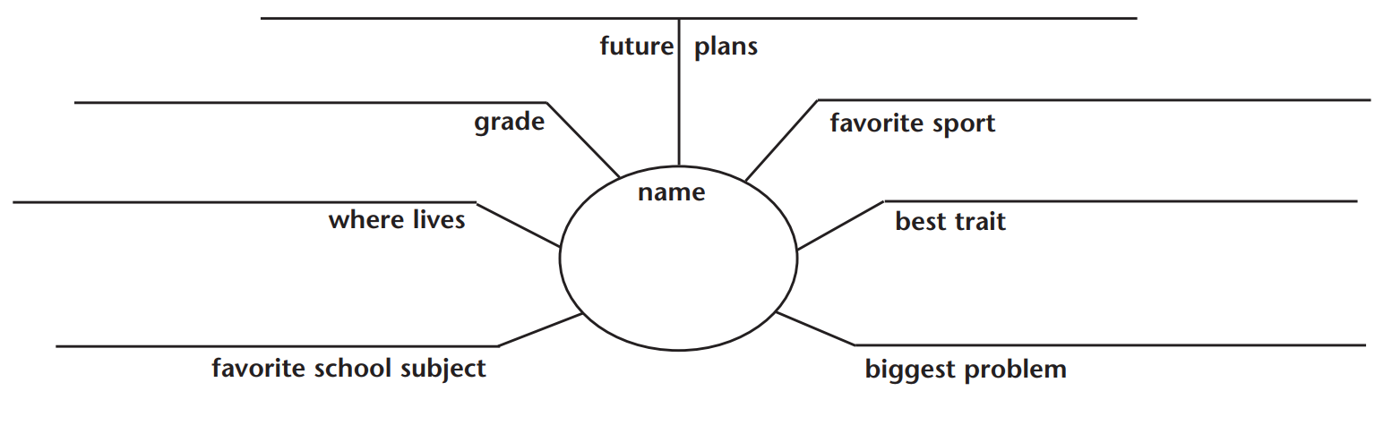

Task 2
Directions: Mapping is simply showing information in a visual way. Read the story below. Then write short sentences or phrases to complete the story elements map.

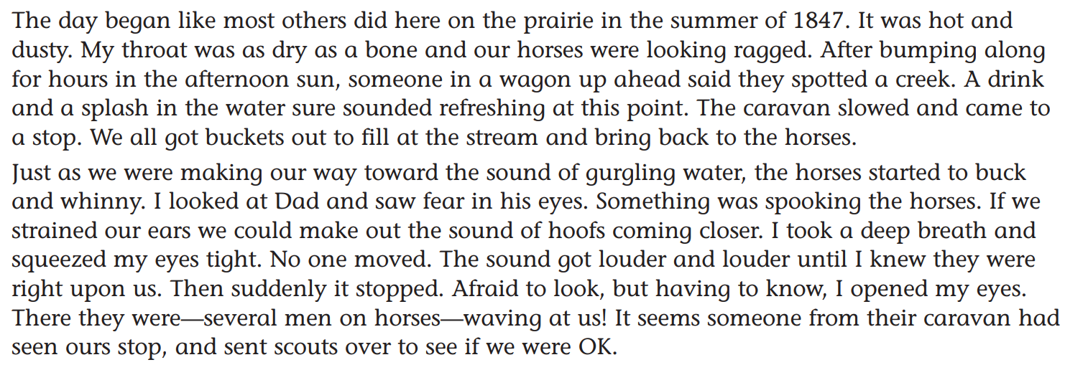
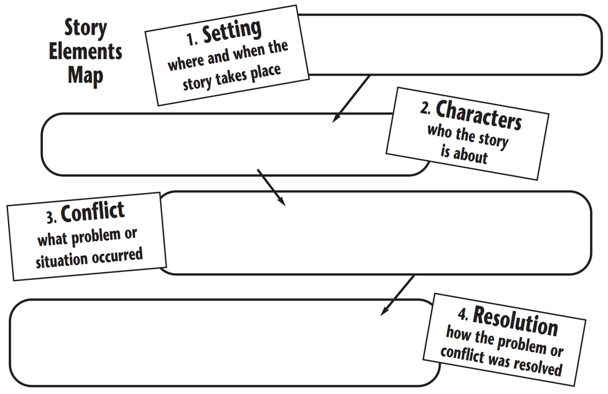
Task 3
Direction: Read the following text, and then make a suitable diagram based on it.

The Nature of Management

Management is the process of getting things done through other people. Some individuals carry the title of manager but are not a manager in the true sense of the word. They may have people reporting to them, but they tend to work alone, seeming to manage their subordinates as an afterthought. Such individuals are basically entrepreneurs, and it is likely that they will find themselves unable to cope with the dynamic changes now confronting modern organizations.
In studying these changes, it is possible to examine them in waves. The first wave started around 8000 BC and was characterized by the agricultural revolution. The second began in the early eighteenth century with industrialization. This wave was characterized by standardization, specialization, synchronization, concentration, maximization, and centralization.
The third wave, which is now beginning to strike the shores of industrial nations, promises to bring dramatic changes and challenges. Some of the major factors which will affect the modern manager’s job are changes in a technological environment, new methods of information handling new employee demand in the world of work organizational loyalty, the evolution of adaptive organizational structures, a redefinition of organizational purpose, and the continued growth of multinational corporations.

Task 4
Direction: Read the following text, and then make a suitable diagram based on it.

Tourists in New York may think it is one big city, but the neighborhoods really are very different. There are rich neighborhoods and poor neighborhoods, and there are neighborhoods full of people from the same country. The people are different and so are the buildings.
For example, in the southern part of the city is New York’s Chinatown. New Yorkers from all parts of the city like to go there. They enjoy shopping at Chinese stores and eating at Chinese restaurants. But most of the people who live in Chinatown are Chinese. The shop signs are all written in Chinese. Everyone in the shops speaks Chinese. This is one of the most crowded and colorful neighborhoods in the city. It is also growing fast. More Chinese people are arriving every day.
Not far from Chinatown is Little Italy. Many Italians moved there from Italy in the early1900s. Some of them stayed in the neighborhood. There are still good Italian shops, restaurants, and cafes in Little Italy. You can hear Italian spoken on the streets. Every year there is a big Italian festival.
Greenwich Village is another kind of neighborhood. There the Buildings are small, old, and comfortable. Twenty-five years ago, the rent for apartments in Greenwich was cheap. Young people with little money often lived there. For many years this was also where writers, artists, and students lived. Famous books were written in the neighborhood. The famous artist painted their first pictures there.
Greenwich Village became more expensive in the 1960s. So, some artists and writers moved down the street to a neighborhood called Soho. There were many old factories in this area Now, most of the old factory buildings are studios for artists. There are many new art galleries, restaurants, and shops. Soon, this neighborhood may also be too expensive for the artist!
The most beautiful and expensive in New York is the Upper East Side. That is where many of the richest people live. The apartment buildings are large and very fancy. The streets are always clean. The shops sell all kinds of special foods and clothing. People from all over the world come to shop on the Upper East Side or they just look in the shop windows and dream.

Task 5
Direction: Read the following text, and then make a suitable diagram based on it.

The house is situated at the bottom of the Chess valley next to the River Chess. It’s about 20 miles from London and just outside the village of Chorleywood. It’s really a splendid period property. The oldest parts are Elizabethan, but there were some additions in the 1820s.
It seems typically English to me. There are long corridors and huge oak-paneled rooms, and you can imagine all sorts of scenes from history taking place here.
As you come in through the front door, you find yourself in a large hall with an open fireplace, which is unusual. One of the doors on the right of the hall leads into the living room. The room faces the south, so it’s very sunny, and it has a lovely view of the whole valley. The furniture has been chosen to match the style of the house, so there’s a lot of leather and dark, heavy wood. Next to this room, there’s the dining room which has French windows leading into a small patio.
Also on the ground floor, there is a study, kitchen, and utility room. A wide staircase takes you to the first floor, where there are five bedrooms. The largest is about 25’ x 20’, a really vast room that looks out onto a garden.
The house is on 2.5 acres of land, and there is a greenhouse, a shed, a swimming pool, and a tennis court.
It’s a beautiful place to be at any time of the year. In winter it’s warm and cozy and there’s so much to do outside in summer.

Task 6
Direction: Read the following text, and then make a suitable diagram based on it.

How Parliament Makes New Laws

New laws can originate in either the House of Lords or the House of Commons. A law that is being proposed is called a ‘bill’ until it is passed; then it becomes an ‘act’ of the parliament.
To begin with, the bill goes through the first reading. This just means that the title of the bill is announced and a time is set for it to be discussed. After this, the second reading is really a debate. The bill may be rejected at this stage. If it is an important bill its rejection may cause the government to resign. On the other hand, it may be passed, or there may be a vote. When this happens, it goes to the committee stage, where a small group of members (perhaps between 30 and 50), meet and discuss it in detail. When the committee has finished its work, it reports the bill with all the changes that have been made, to the House. This is called the report stage. The bill is discussed again, and more changes can be made. Then the bill is taken for its third reading and a vote is taken. When it is passed, it goes to the other House, i.e. not the one it originated in. So if a bill started in the House of Commons it would, at this point, go to the House of Lords.
When the boll has been passed by both Houses, it goes to the Queen for Royal Assent. A bill may not become law until the Royal Assent has been given, but this does not mean that the queen decides on what will become law and what will not. It is understood that the queen will always accept bills that have been passed by both Houses. When the Queen’s consent has been given, the bill becomes an act, and everyone that it affects must obey the new law.

Task 7
Direction: Read the following text, and then make a suitable diagram based on it.
Jakarta, 8 Jan 8 (JPS) – A boy kisses his mother before going to school. Unknown to his mother, he keeps a sickle in his bag. Soon after hopping onto a packed public bus, a fight erupts between him and his classmates and students from a rival school who are armed with machetes, sharpened bamboo spears and stones. The boy is struck by a machete wielded by a ‘rival’ youngster, and is left dying on the road. The scene appears in one of the television advertisement aired by the Ministry of National Education, aimed at stopping student brawls that have become a common sight in Jakarta and other big cities in Indonesia.
Known in Indonesian as ‘tawu-ran’, students brawls often end with fatalities. The fights which frequently occur outside class-rooms and when students are in groups on the way to their schools and homes, led to dozens of deaths last year. “The problem of student brawls is complicated issue.” Says Indra Djati Sidi, Director-general of Elementary at the Ministry of National Education
Education experts attribute the frequency of these brawls to factors ranging from competition to the use of illegal drugs, which education officials consider the number one problem among youth today. There are other signs of restlessness among youngsters in a society in transition like Indonesia, others say. “The fights are also related to the movies and passing of tradition by the senior high school students to their juniors,” Sidi says.
The wave of violence also worries some students. “We are tired of seeing ‘tawuran’. Students involved in the fights should be punished. They should be dismissed,” says a junior high school student Alvina. “it is really scary to see them (students) waving sickles and machetes and throwing stones at each other,” she adds. “Only cowards fight in street brawls,” argues Edgar, a junior high school student who swears he has never been involved in a brawl.

At present, the education ministry gives students who are caught engaging in brawls warnings or “educational punishments” such as summoning their parents or guardians to school. Education and police authorities have also taken to making sudden visits to schools and weapons–sweeping operations to discourage student brawls, but stopping them will not be easy.

